Gas detector alarm using mq-6 & Arduino_UNO

PCB designing.

Schematic Diagram:

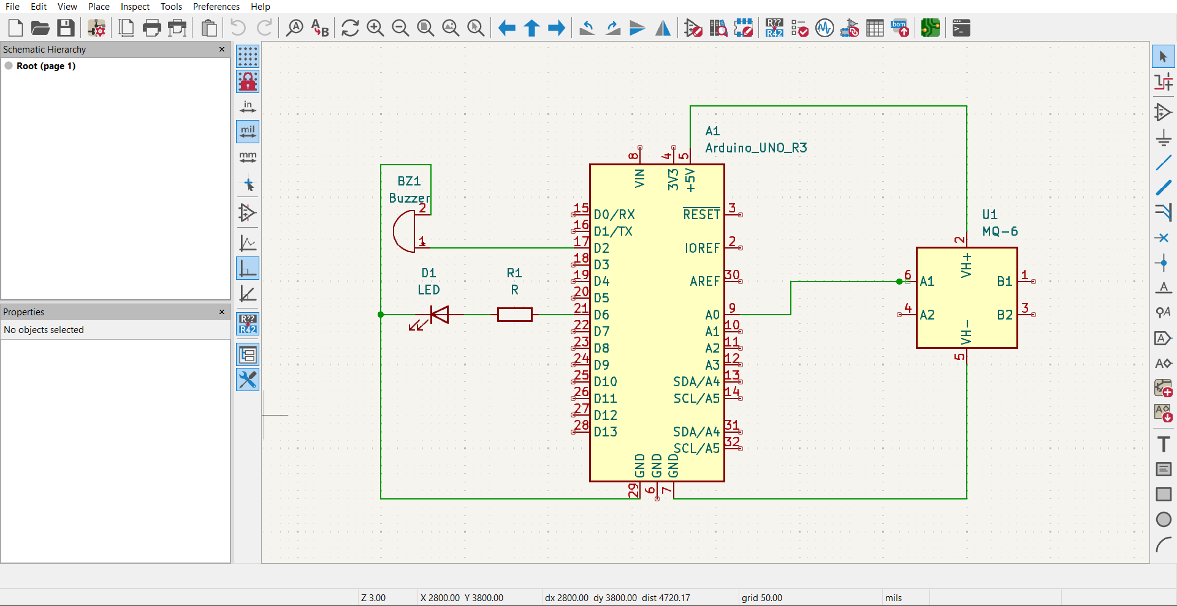

PCB design:

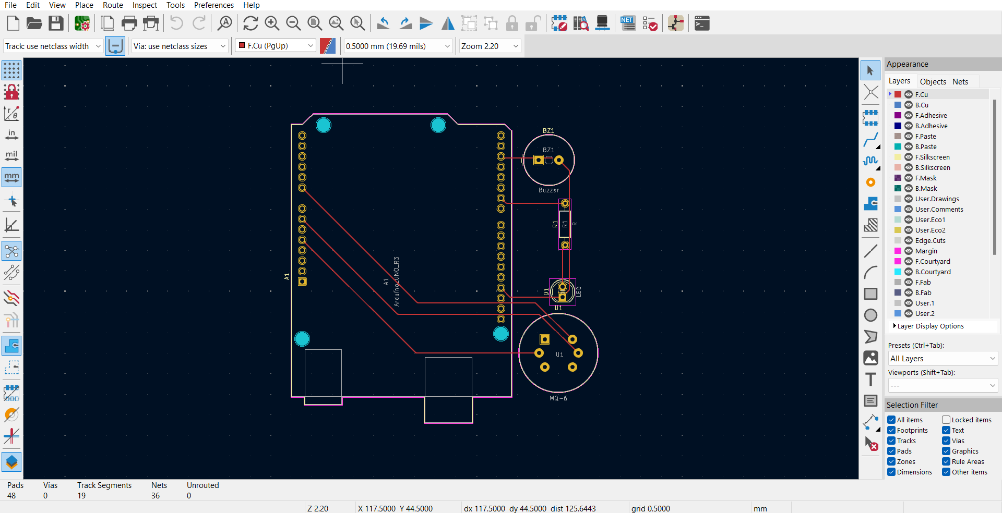

3D Model:

